A+

95/100

Criteria

Instructions Followed

Timeliness

15% Script & Storyboard (needs quote)

Script Template Quality - Excellent coordination of audio, text and image. Audio script is well organized, interesting, retells story accurately and is marked up with accurate time signatures connected to images. Images and image details are well chosen. Transitions are thoughtful and effective.

The script was very well written, clearly planned and very entertaining.

10% Digital Assets

Digital Assets - Digital assets are correctly inventoried and linked. Images are of sufficient resolution and in jpg format. Audio Recording is clearly and compellingly recorded in .mp3 format

The audio recording and background music was exceptional. The use of a second voice really added character to the project. The additional images you created added a lot to the work as well.

10% Multimedia Web Animation

Coding Quality - CODEPEN is successful

Exceptional work! The animations were very effective. The first animation was a bit too far to the left.

**AUDIO SCRIPT (530 words)**

**Al-Harith: Paranoid or Perceptive? :** Maqama 13- The Story ‘Of Bagdad’

Author: SADIQ SHAMJI

Key:

Red Writing = Transition Type

Blue Writing = Sound Effect

**Part 1**

In Maqamah Thirteen, which is the story ‘of Baghdad’, Al Harith is engaged in intellectual conversation with a group of poets.

Duration: 12 Seconds

[Zoom into crowd]

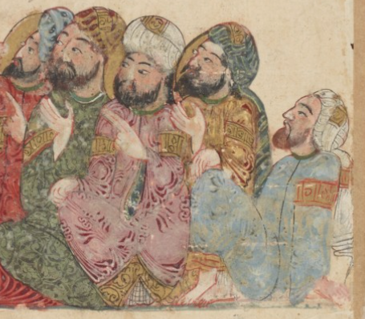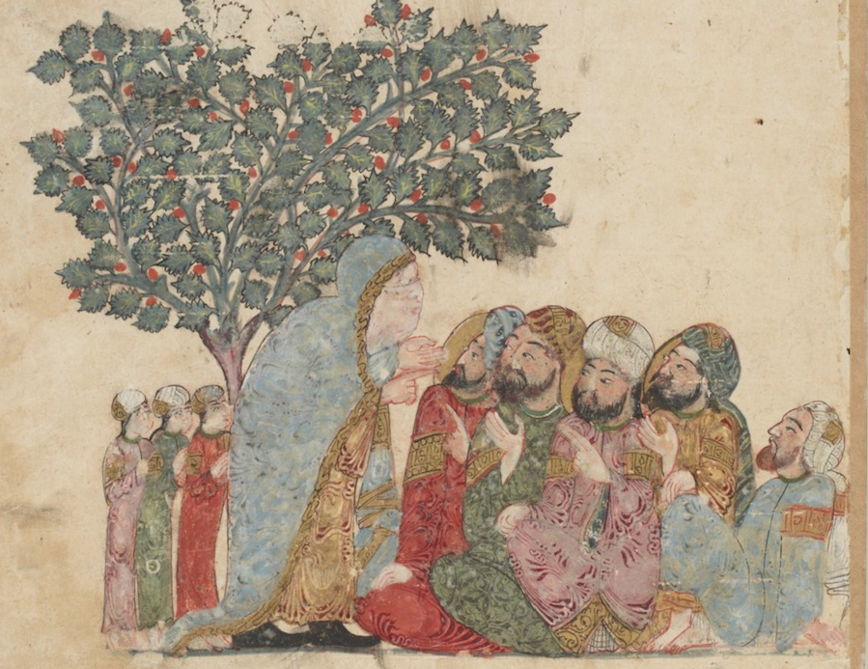

Their discussion is cut short by an old and feeble woman. Standing next to her were three feeble and hungry children, their hanging on their slim figures like curtains.

[Melancholic music]

Duration: 10 Seconds

[Pan left to show woman and children]

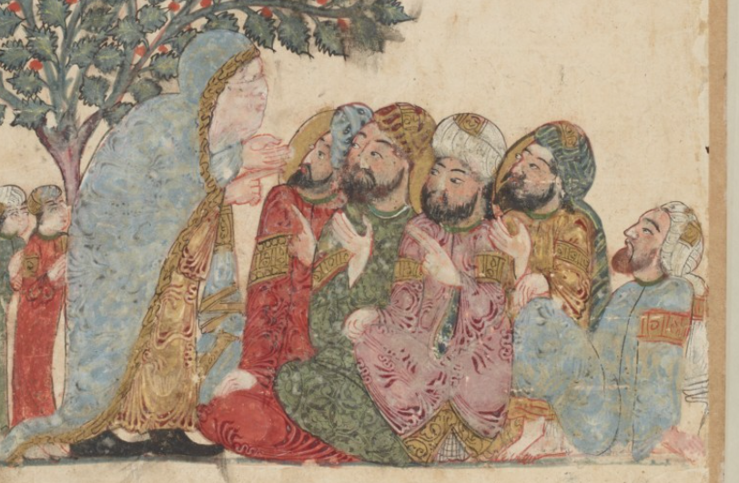

Driven by desperation, she beseeches the crowd to give her something to ease her burden. Her old age and poverty have made her weak and hungry and have done the same to the children.

[Music Ascends]

[Centralize on woman]

She spoke first of the hardships of poverty and her everyday labour.

Woman: *“To burden the back, destroyed the arms and pained the liver…Hands became dry and elbows gave way until there was nothing left to carry with”.*

[Zoom in slowly to woman]

But the old woman did not just come to anyone for help. No. And she definitely did not just go to the rich…

[Music Continues]

[Jump cut to crowd and pan back to woman]

Woman**:** *“Now, I had sworn I would not shame myself in asking anyone for money, except those who I know are generous. I would rather die of misery than lose my dignity”.*

The men were surprised. How could such a poor woman speak with such eloquence? Little did they know that she was not only well spoken… but a poet.

[Hopeful Music]

[Zoom in and pan upwards to tree]

Duration: 27 Seconds

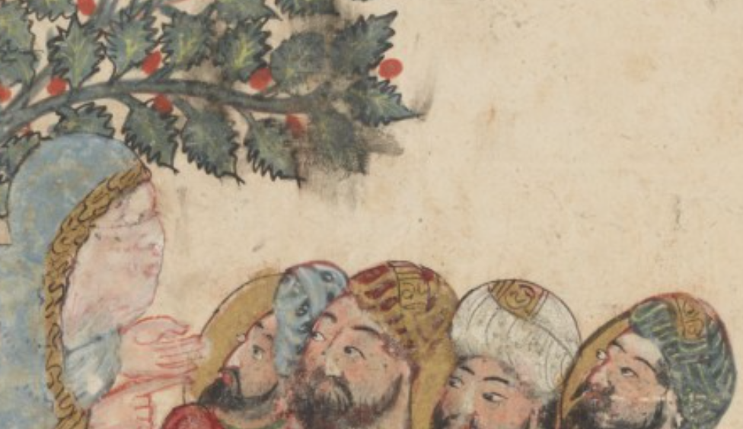

Woman:

*“The black hair of my temples has been whitened”*

*“Their fires were kindled to the travellers and they fed the guests”*

*“O Thou who feedest the young raven in the nest”*

*“Appoint us, O God, one whose honour is pure and washed from the filth of blame; who will quench for us the fire of hunger”*

[Musical Climax]

[Zoom out quickly]

The men were struck with emotion **“She cleft our heart in pieces, and called forth the gifts of our bosoms”** Al-Harith said. And with that the men generously paid her in gold until she could not carry any more.

[Clinking sound of coins]

[Zoom into Gold clothing]

Duration: 4 Seconds

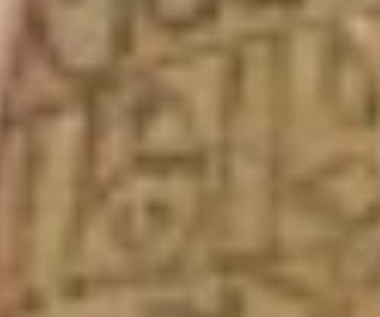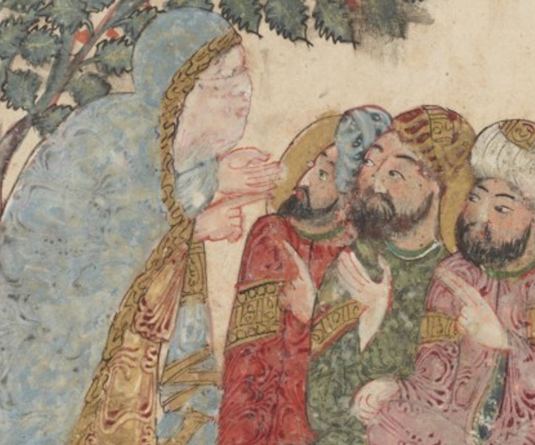

And so she and the children went on their way.

[Music Stops]

[Fade to black]

**Part 2:**

There was, however, a hint of suspicion for Al-Harith. [Picture of Al-Harith]

This felt all too familiar for him. This felt like the working of an old friend…[Zoom out to show Abu Zayd]

Duration: 5 Seconds

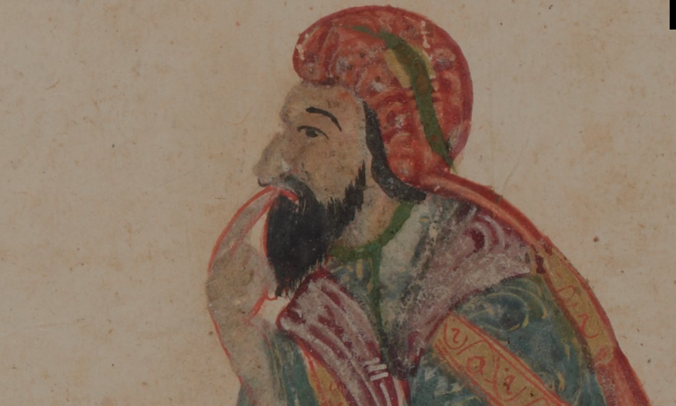

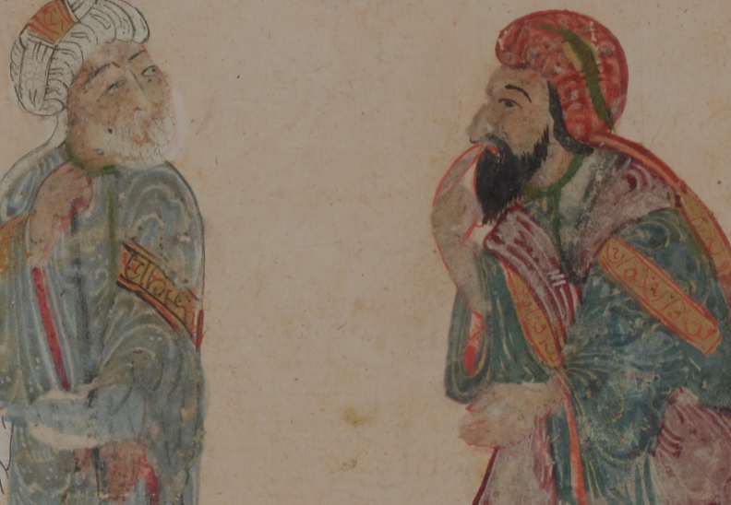

Perhaps he was becoming too paranoid, the thought. How could he suspect such a poor old woman? And he was ashamed. But then… an image popped into his head

[Tense Music Begins]

[Picture of Smiling Al-Harith, panning to left]

Duration: 11 Seconds

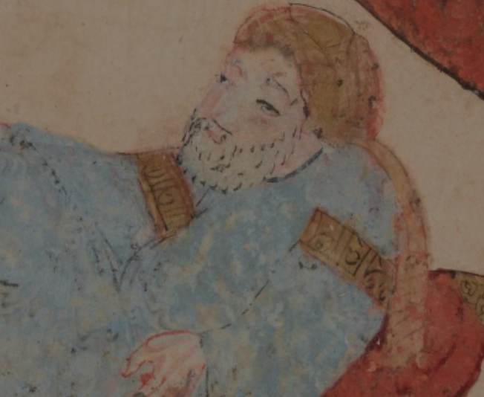

… a face that he knew to well, grinning maliciously, and he could not stay still.

**Part 3:**

And so he followed the woman. He followed her as she entered a busy market

[Market sounds]: Talking and Tabla

Duration: 15 Seconds

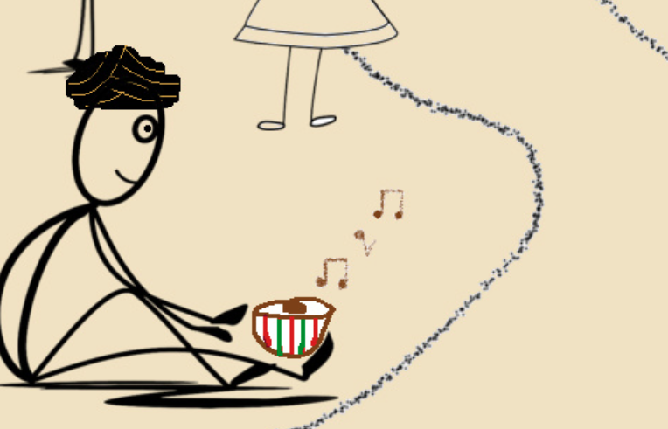[Pan Around Drawing of Market]

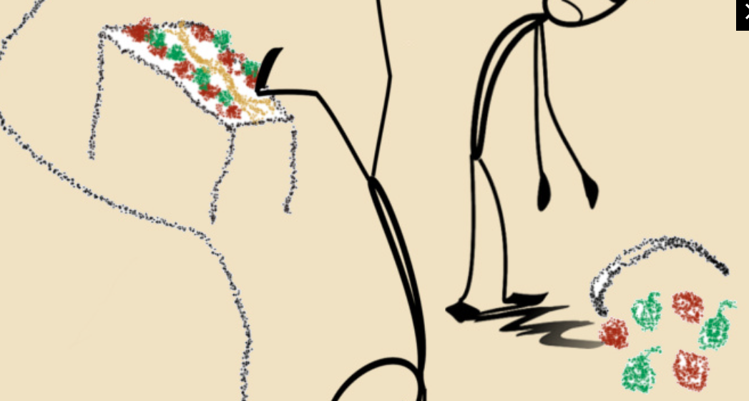

Amidst all the chaos she got separated from the three kids [Climax]. Al-Harith still kept on her tail until she passed through the crowd, finally entering a ruined mosque

[Door Slam]

Duration: 2 Seconds

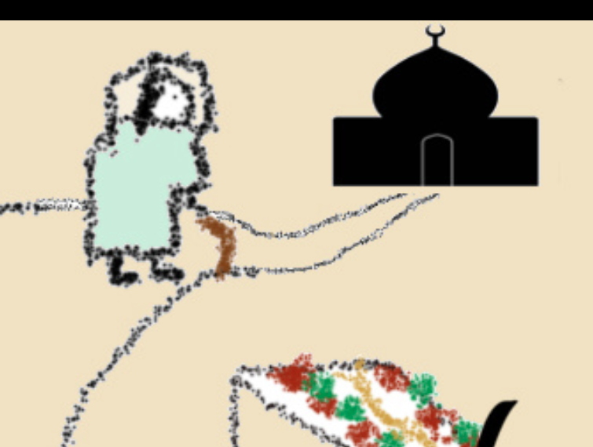[Zoom into Mosque]

Through the keyhole, he watched closely as the woman removed her veil, and underneath it, none other than ABU ZAYD.

[Zoom into Keyhole]

[Appear Abu Zayd]

Duration: 10 Seconds

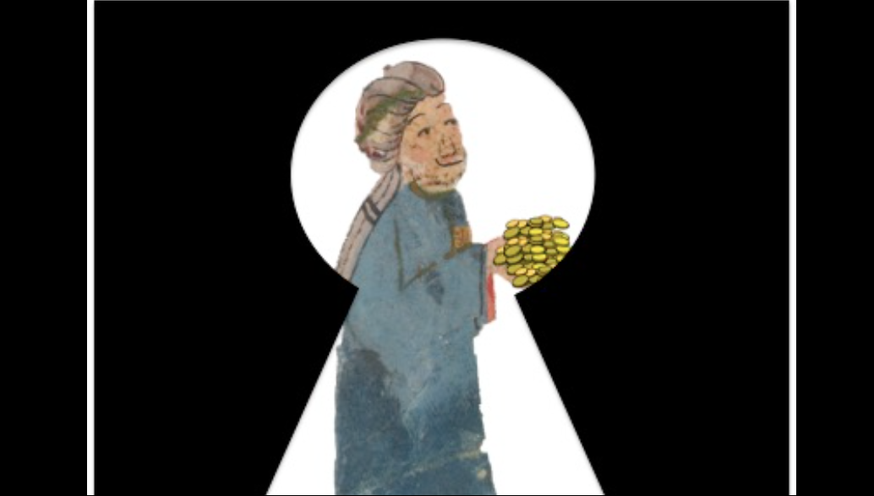

[Fade to Black]

Sources Used for Project:

**Works Cited**

Abu Mohammad al-Qasim ibn'Ali ibn Muhammad ibn'Ali al-Hariri al-Basri. Author of the. "The Makamat of Hariri; exemplary adorned with paintings executed by Yahya ibn Mahmud ibn Yahya bin Abul-Hasan ibn Kouvarriha al-Wasiti." Southern Iraq, 1237.

Al-Hariri, Abu Muhammad. Assemblies of Al Hariri Volume 1. Translated by Thomas Chenery and F. Steingass. London: Princeton university, 1867.

Freesound Team. freesound. 2017. https://freesound.org/home/ (accessed 11 15, 2017). This animation uses these sounds from freesound:

"Leipzig - city sounds » weekly market" by "pillonoise"

"Door Slam" by "viznoman"

"Tabla Loop Shuffle" by "c0mp0s3r"

"Herat synth atmospheres » Herat 4.mp3" by "ERH"

pixabay. Beautiful Free Images. 2017. https://pixabay.com (accessed 11 15, 2017).